UC_01: Consult Menu (Scénario) → A

UC_02: Create account (Scénario) →S

UC_03: Authentication → A

UC_04: Add item to cart → S

UC_05: Consult cart → A

UC_06: Order → S

UC_07: Give an opinion → A

UC_08: Manage Account → S

UC_09: Sign Restaurant→ A

UC_10: Manage Orders → S

UC_11: Manage Menu → S

|  |
| --- |
| ***Consult Menu***  **Identifier**:  UC_01  **Actors:**  Visitors  **Description:**  Everyone can consult menu, dishes, and global note.  **Preconditions:**   * 1. Application has been installed and launched.   2. Updated application.   3. Optional (authenticated).   **Assumptions:**   * 1. Network connexion established.   2. Database is online.   3. Restaurant and menus exist.   **Basic course:**  1. First screen: restaurant list.  User chooses the restaurant on the list and check the stars awarded to a restaurant.  2. Second screen: menus & dishes list. Applications displays all of menus and dishes, their brief descriptions and price. The user can check price of all menu or dishes. Also, he can check the overall rating and comments of other users about the restaurant.  3. Third screen: menu/dishes details. The user can check details of menu/dishes.  **Alternate course:**  **Case A:**  Database is offline.  Display error message.  **Case B:**  1. Button refresh has been selected.  Refresh list of Restaurant  **Case C:**  Screen 1/2/3. User click on Sign-up  Go to CREATE ACCOUNT (UC_2 )  **Case D:**  Screen 1/2/3. User click on Login  Go to AUTHENTICATION (UC_3 )  **Case E:**  2. URL comment selected.  Displays all of comments (box pop).  **Case F:**  Screen 2,3. Click on return  Go to Previous page. |

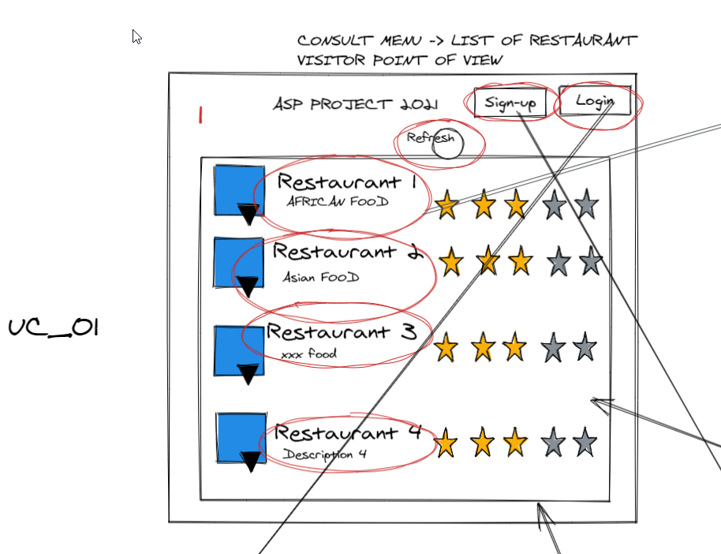

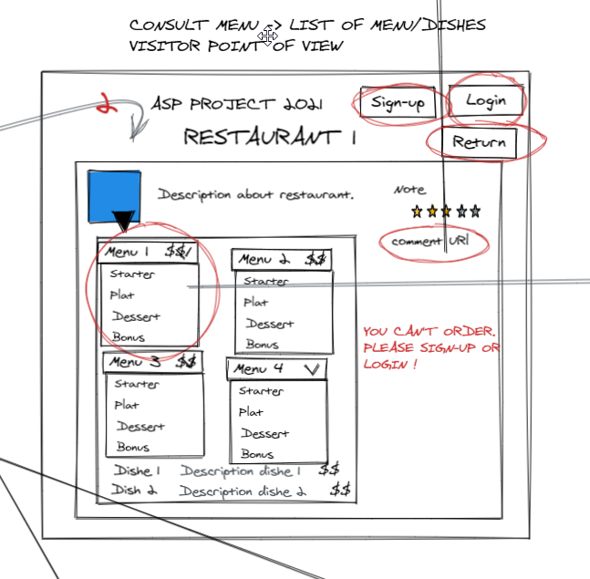

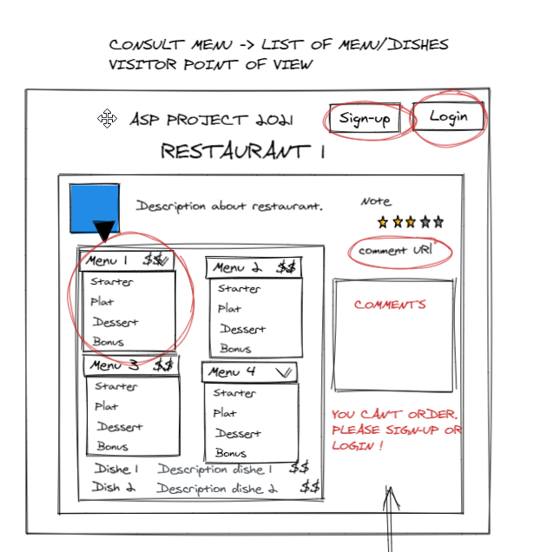

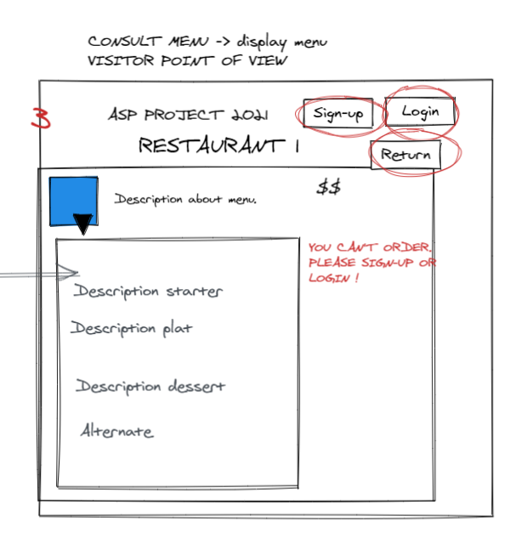

|  |
| --- |
| ***Authentication***  **Identifier**:  UC_03  **Actors:**  Customer and restorer.  **Description:**  The user can connect to the Application.  **Preconditions:**  1. UC_2  2. User clicked on “login” button.  **Assumptions:**  1. Network connexion established.  2. Database is online.  3. Restaurant and menus exist.  **Basic course:**  1.    **Alternate course:**  **Case A:**  Database is offline.  Display error message.  **Case B:**  1. Button refresh has been selected.  Refresh list of Restaurant  **Case C:**  Screen 1/2/3. User click on Sign-up  Go to CREATE ACCOUNT (UC_2 )  **Case D:**  Screen 1/2/3. User click on Login  Go to AUTHENTICATION (UC_3 )  **Case E:**  2. URL comment selectionned.  Displays all of comments.  **Case F:**  Screen 2,3. Click on return  Go to Previous page. |